**Convolutional Neural Networks**

One major problem with computer vision problems is that the input data can get really big. Suppose an image is of the size 68 X 68 X 3. The input feature dimension then becomes 12,288. This will be even bigger if we have larger images (say, of size 720 X 720 X 3). Now, if we pass such a big input to a neural network, the number of parameters will swell up to a HUGE number (depending on the number of hidden layers and hidden units). This will result in more computational and memory requirements – not something most of us can deal with.

**Edge Detection Example**

In this section, we will focus on how the edges can be detected from an image. Suppose we are given the below image:



As you can see, there are many vertical and horizontal edges in the image. The first thing to do is to detect these edges:

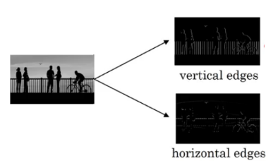

But how do we detect these edges? To illustrate this, let’s take a 6 X 6 grayscale image (i.e. only one channel):

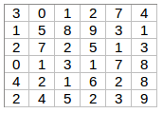

Next, we convolve this 6 X 6 matrix with a 3 X 3 filter:

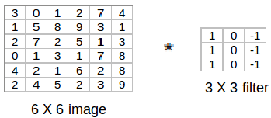

After the convolution, we will get a 4 X 4 image. The first element of the 4 X 4 matrix will be calculated as:

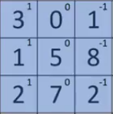

So, we take the first 3 X 3 matrix from the 6 X 6 image and multiply it with the filter. Now, the first element of the 4 X 4 output will be the sum of the element-wise product of these values, i.e. 3*1 + 0 + 1*-1 + 1*1 + 5*0 + 8*-1 + 2*1 + 7*0 + 2*-1 = -5. To calculate the second element of the 4 X 4 output, we will shift our filter one step towards the right and again get the sum of the element-wise product:

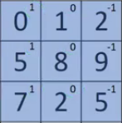

Similarly, we will convolve over the entire image and get a 4 X 4 output:

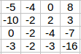

So, convolving a 6 X 6 input with a 3 X 3 filter gave us an output of 4 X 4. Consider one more example:

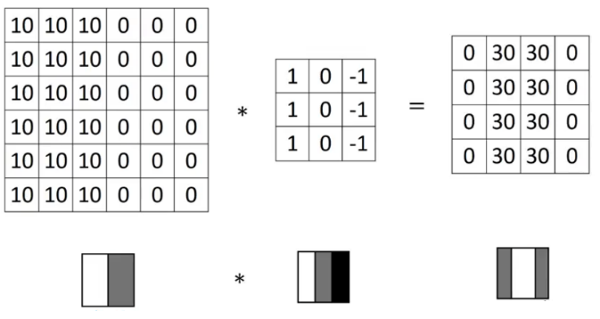

**Note**: Higher pixel values represent the brighter portion of the image and the lower pixel values represent the darker portions. This is how we can detect a vertical edge in an image.

**More Edge Detection**

The type of filter that we choose helps to detect the vertical or horizontal edges. We can use the following filters to detect different edges:

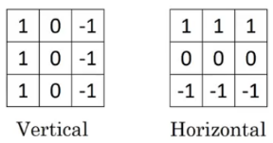

Some of the commonly used filters are:

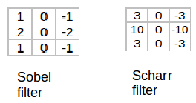

The Sobel filter puts a little bit more weight on the central pixels. Instead of using these filters, we can create our own as well and treat them as a parameter which the model will learn using backpropagation.

Padding

We have seen that convolving an input of 6 X 6 dimension with a 3 X 3 filter results in 4 X 4 output. We can generalize it and say that if the input is n X n and the filter size is f X f, then the output size will be (n-f+1) X (n-f+1):

* **Input:** n X n
* **Filter size:** f X f
* **Output:** (n-f+1) X (n-f+1)

There are primarily two disadvantages here:

1. Every time we apply a convolutional operation, the size of the image shrinks
2. Pixels present in the corner of the image are used only a few number of times during convolution as compared to the central pixels. Hence, we do not focus too much on the corners since that can lead to information loss

To overcome these issues, we can pad the image with an additional border, i.e., we add one pixel all around the edges. This means that the input will be an 8 X 8 matrix (instead of a 6 X 6 matrix). Applying convolution of 3 X 3 on it will result in a 6 X 6 matrix which is the original shape of the image. This is where padding comes to the fore:

* **Input:** n X n
* **Padding:** p
* **Filter size:** f X f
* **Output:** (n+2p-f+1) X (n+2p-f+1)

There are two common choices for padding:

1. **Valid:** It means no padding. If we are using valid padding, the output will be (n-f+1) X (n-f+1)
2. **Same:** Here, we apply padding so that the output size is the same as the input size, i.e.,  
   n+2p-f+1 = n  
   So, p = (f-1)/2

We now know how to use padded convolution. This way we don’t lose a lot of information and the image does not shrink either. Next, we will look at how to implement strided convolutions.

**Strided Convolutions**

Suppose we choose a stride of 2. So, while convoluting through the image, we will take two steps – both in the horizontal and vertical directions separately. The dimensions for stride *s* will be:

* **Input:** n X n
* **Padding:** p
* **Stride:** s
* **Filter size:** f X f
* **Output:** [(n+2p-f)/s+1] X [(n+2p-f)/s+1]

Stride helps to reduce the size of the image, a particularly useful feature.

**Convolutions Over Volume**

Suppose, instead of a 2-D image, we have a 3-D input image of shape 6 X 6 X 3. How will we apply convolution on this image? We will use a 3 X 3 X 3 filter instead of a 3 X 3 filter. Let’s look at an example:

* **Input:** 6 X 6 X 3
* **Filter:** 3 X 3 X 3

The dimensions above represent the height, width and channels in the input and filter. ***Keep in mind that the number of channels in the input and filter should be same.*** This will result in an output of 4 X 4. Let’s understand it visually:

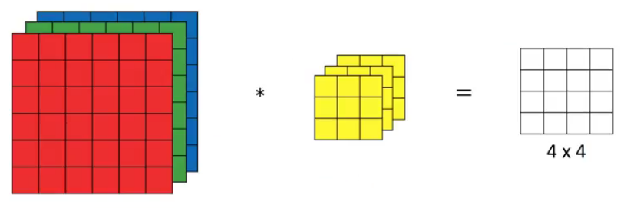

Since there are three channels in the input, the filter will consequently also have three channels. After convolution, the output shape is a 4 X 4 matrix. So, the first element of the output is the sum of the element-wise product of the first 27 values from the input (9 values from each channel) and the 27 values from the filter. After that we convolve over the entire image.

Instead of using just a single filter, we can use multiple filters as well. How do we do that? Let’s say the first filter will detect vertical edges and the second filter will detect horizontal edges from the image. If we use multiple filters, the output dimension will change. So, instead of having a 4 X 4 output as in the above example, we would have a 4 X 4 X 2 output (if we have used 2 filters):

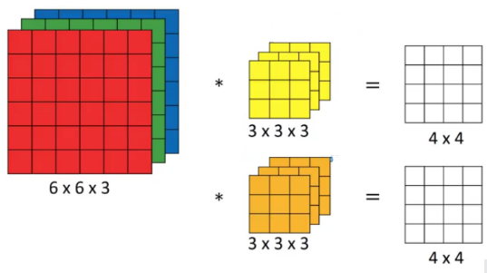

Generalized dimensions can be given as:

* **Input:** n X n X nc
* **Filter:** f X f X nc
* **Padding:** p
* **Stride:** s
* **Output:** [(n+2p-f)/s+1] X [(n+2p-f)/s+1] X nc’

Here, nc is the number of channels in the input and filter, while nc’ is the number of filters.

**One Layer of a Convolutional Network**

Once we get an output after convolving over the entire image using a filter, we add a bias term to those outputs and finally apply an activation function to generate activations. *This is one layer of a convolutional network*. Recall that the equation for one forward pass is given by:

z[1] = w[1]*a[0] + b[1]  
a[1] = g(z[1])

In our case, input (6 X 6 X 3) is a[0]and filters (3 X 3 X 3) are the weights w[1]. These activations from layer 1 act as the input for layer 2, and so on. Clearly, the number of parameters in case of convolutional neural networks is independent of the size of the image. It essentially depends on the filter size. Suppose we have 10 filters, each of shape 3 X 3 X 3. What will be the number of parameters in that layer? Let’s try to solve this:

* Number of parameters for each filter = 3*3*3 = 27
* There will be a bias term for each filter, so total parameters per filter = 28
* As there are 10 filters, the total parameters for that layer = 28*10 = 280

No matter how big the image is, the parameters only depend on the filter size. Awesome, isn’t it? Let’s have a look at the summary of notations for a convolution layer:

* f[l] = filter size
* p[l] = padding
* s[l] = stride
* n[c][l] = number of filters

Let’s combine all the concepts we have learned so far and look at a convolutional network example.

**Simple Convolutional Network Example**

This is how a typical convolutional network looks like:

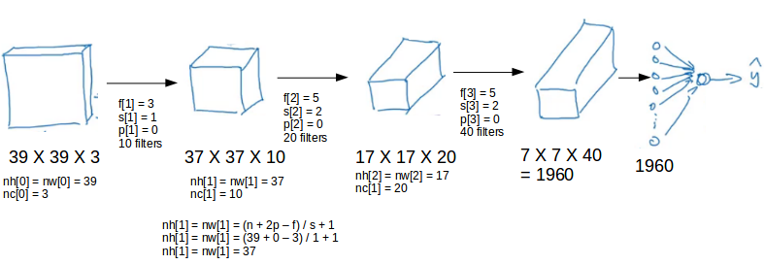

We take an input image (size = 39 X 39 X 3 in our case), convolve it with 10 filters of size 3 X 3, and take the stride as 1 and no padding. This will give us an output of 37 X 37 X 10. We convolve this output further and get an output of 7 X 7 X 40 as shown above. Finally, we take all these numbers (7 X 7 X 40 = 1960), unroll them into a large vector, and pass them to a classifier that will make predictions. This is a microcosm of how a convolutional network works.

There are a number of hyperparameters that we can tweak while building a convolutional network. These include the number of filters, size of filters, stride to be used, padding, etc. We will look at each of these in detail later in this article. Just keep in mind that as we go deeper into the network, the size of the image shrinks whereas the number of channels usually increases.

In a convolutional network (ConvNet), there are basically three types of layers:

1. Convolution layer
2. Pooling layer
3. Fully connected layer

Let’s understand the pooling layer in the next section.

**Pooling Layers**

Pooling layers are generally used to reduce the size of the inputs and hence speed up the computation. Consider a 4 X 4 matrix as shown below:

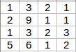

Applying max pooling on this matrix will result in a 2 X 2 output:

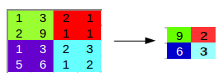

For every consecutive 2 X 2 block, we take the max number. Here, we have applied a filter of size 2 and a stride of 2. These are the hyperparameters for the pooling layer. Apart from max pooling, we can also apply average pooling where, instead of taking the max of the numbers, we take their average. In summary, the hyperparameters for a pooling layer are:

1. Filter size
2. Stride
3. Max or average pooling

If the input of the pooling layer is nh X nw X nc, then the output will be [{(nh – f) / s + 1} X {(nw – f) / s + 1} X nc].

**CNN Example**

We’ll take things up a notch now. Let’s look at how a convolution neural network with convolutional and pooling layer works. Suppose we have an input of shape 32 X 32 X 3:

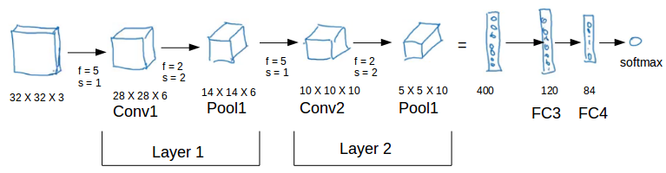

There are a combination of convolution and pooling layers at the beginning, a few fully connected layers at the end and finally a softmax classifier to classify the input into various categories. There are a lot of hyperparameters in this network which we have to specify as well.

Generally, we take the set of hyperparameters which have been used in proven research and they end up doing well. As seen in the above example, the height and width of the input shrinks as we go deeper into the network (from 32 X 32 to 5 X 5) and the number of channels increases (from 3 to 10).

All of these concepts and techniques bring up a very fundamental question – why convolutions? Why not something else?

Module 2: Deep Convolutional Models: Case Studies

Classic Networks

In this section, we will look at the following popular networks:

1. LeNet-5
2. AlexNet
3. VGG

We will also see how ResNet works and finally go through a case study of an inception neural network.

***LeNet-5***

Let’s start with LeNet-5:

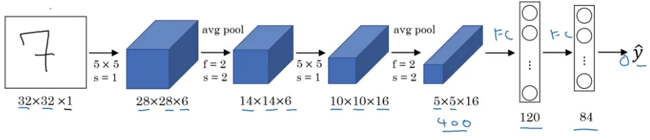

It takes a grayscale image as input. Once we pass it through a combination of convolution and pooling layers, the output will be passed through fully connected layers and classified into corresponding classes. The total number of parameters in LeNet-5 are:

* **Parameters:** 60k
* **Layers flow:** Conv -> Pool -> Conv -> Pool -> FC -> FC -> Output
* **Activation functions:** Sigmoid/tanh and ReLu

***AlexNet***

An illustrated summary of AlexNet is given below:

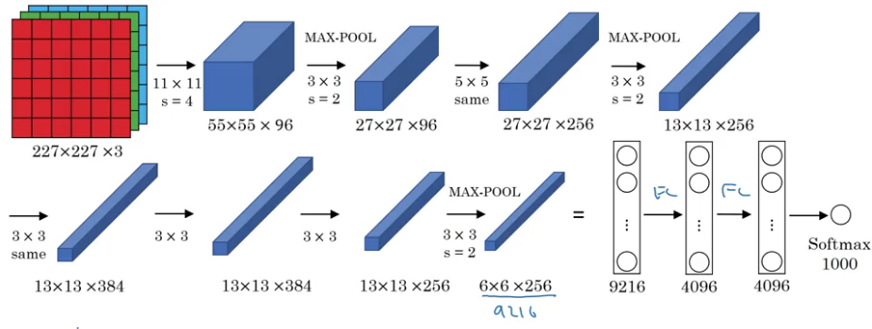

This network is similar to LeNet-5 with just more convolution and pooling layers:

* **Parameters:** 60 million
* **Activation function:** ReLu

***VGG-16***

The underlying idea behind VGG-16 was to use a much simpler network where the focus is on having convolution layers that have 3 X 3 filters with a stride of 1 (and always using the same padding). The max pool layer is used after each convolution layer with a filter size of 2 and a stride of 2. Let’s look at the architecture of VGG-16:

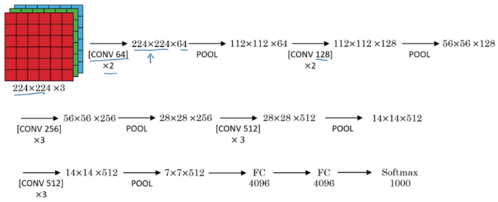

As it is a bigger network, the number of parameters are also more.

* **Parameters:** 138 million

These are three classic architectures. Next, we’ll look at more advanced architecture starting with ResNet.